**ST.ANN’S COLLEGE OF ENGINEERING & TECHNOLOGY**

**DEPARTMENT OF ELECTRICAL AND ELECTRONICS ENGINEERING**

(Accredited twice by **NBA**, **IE(I)Kolkata**,**& NAAC** With “**A”** GRADE approved

by AICTE, NEWDELHI & Permanently AFFLIATED TO JNTUK,KAKINADA)

**2010-2014**

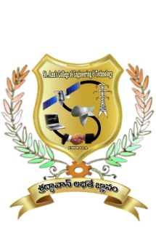

**CERTIFICATE**

This is to certify that the project work entitled **“IMPROVING POWER SYSTEM STABILITY USING STATIC SYNCHRONOUS SERIES COMPENSATOR”** thatis being submitted by **Mr.**  bearing **Roll. No:** in partial fulfilment of the requirement for the award of the degree of **Bachelor of Technology in ELECTRICAL AND ELECTRONICS ENGINEERING** of **Jawaharlal Nehru Technological University Kakinada, Kakinada** isa record of bonafide work carried out by himunder my guidance and supervision during the academic year 2013-2014.

Viva voce date:

**Mr.S.V.D.ANIL KUMAR,M.Tech,Ph.D**

**Head of the Department**

**Mr.Y.NARAYANARAO M.Tech**

**Project Guide.**

**EXTERNAL EXAMINER**